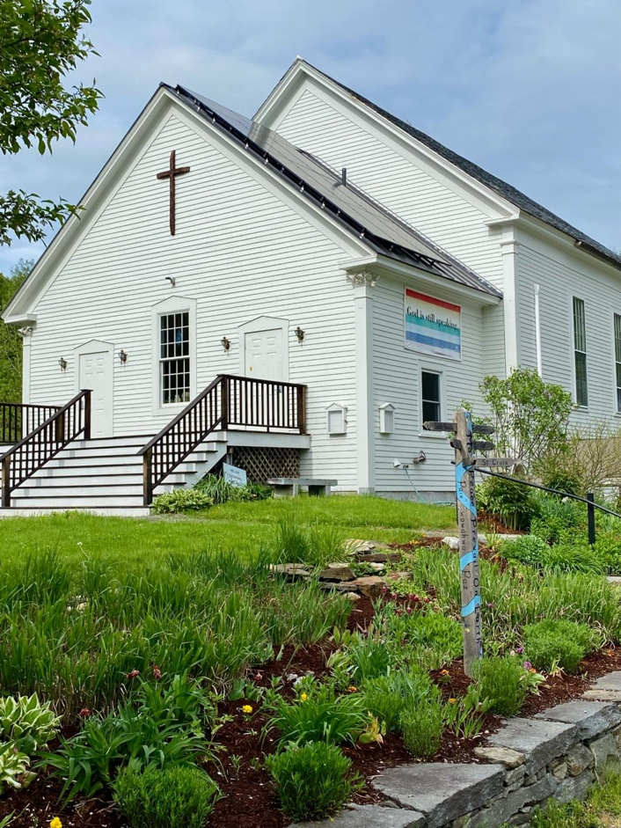

Guilford Community Church
October 26, 2025

Worship leader: Pastor Allyson Platt
Choir Director: Stefan Amidon
Accompanist: Andy Davis

It is exciting to come to Guilford Community Church and be at home in our sanctuary among our family in Christ. What joy we have greeting one another! Let us also bring our hearts and minds to the act of worship when the prelude begins.

Prelude

Greetings/Welcome/Announcements

Introit No Act of Kindness, No Matter How Small

Lighting the candles & Silent meditation

Call to Worship From Psalm 23

Leader: The Lord is My Shepherd, I shall not want. He makes me lie down in green pastures. He leads me beside still waters. He restores my soul.

All: He sets a table before me in the presence of my enemies. He anoints my head with oil. My cup overflows.

Leader: Even though I walk through the valley of the shadow of death, I will fear no evil. For You are With Me Lord. Your rod and staff give me comfort.

All: Surely goodness and mercy shall follow me all the days of my life, and I shall dwell in the House of the Lord forever.

prayer of invocation
opening hymn #7 “Joyful, Joyful, We Adore Thee”

prayer of confession

All: Almighty and Most Merciful Creator. Please grant us Your Mercy. We have often erred and strayed from your ways like lost sheep. We have followed too much the desires of our own hearts, and not acted as you have taught us to act. We have left undone those things which we ought to have done, and we have done those things which we ought not to have done. Help us now to follow in the way of Jesus, Our Savior. For whose sake, and with whose help, we would live in service to your principles, honoring the glory of Your Creation. Amen.

silence

words of assurance

First Anthem By the Waters of Babylon - words and music by Brent Dowe, James A. McNaughton, George Reyam and Frank Farian
arr. Ysaye Barnwell, transcribed and adapted by Peter Amidon

Children’s message

hymn #54 “For the Beauty of the Earth”
congregation may remain seated

scripture readings Rachel Johnson
Joel 2:23-32 (p.799); Psalm 84: 1-7 (p.513); Luke 18: 9-14 (p76)

response: write these words #298

sermon

second anthem The Storm Is Passing Over -
By Charles Tindley - arr. Ysaye Barnwell - transcribed and adapted by Andy Davis

prayers of the people Patrice Murray

lord’s prayer

response: hear our prayer, o lord #278

*call for offering

*doxology #46

*dedication

*passing the peace

Closing Hymn #404 “Love Divine All Loves Excelling”
(Taking the Light Out Into the World)

benediction A Gaelic Blessing

threefold amen

postlude

We wish to thank the following individuals, without whom our service would not be possible:
Service Coordinator: Elizabeth Christie
Greeters: Kachina Lee-Autenrieth, Ron Autenrieth, Mary Piluski
Flowers: Rachel Ebersole
Fellowship Hour: Carole Crompton, Terry Sylvester, Joan Wesolowski
Christian education: JoAnne Heckman, Batunga Bibimba

